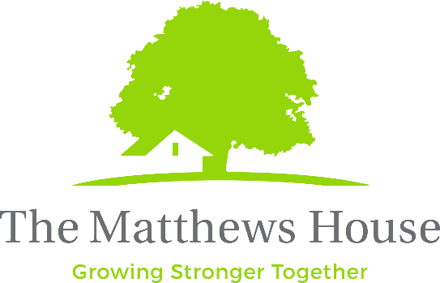
Live the Victory, Inc.

415 Mason Ct. #1

Fort Collins, CO 80524

Federal ID# 20-2894339

EQUAL OPPORTUNITY EMPLOYMENT & AFFIRMATIVE ACTION

The Matthews House is dedicated to the principles of equal employment opportunity in any term, condition, or privilege of employment. We do not discriminate against applicants or employees on the basis of age, race, sex, color, religion, national origin, disability or any other status protected by state or local law.

Internship: Summer Kids Program
Our Summer Zone program for kids is a summer extension of our after-school program (Homework Helpers) that operates Monday-Thursday afternoons and possibly Fridays. We serve children entering grades 1-9 by providing enrichment opportunities for students during the summer months. The Summer Zone Coordinators will lead the program with the help of volunteers, interns, and other staff. The goal is to provide a positive social and recreation environment that meets the needs of our clientele and facilitates a healthy and happy summer learning environment for the children of Fort Collins.

Supervised by: Summer Zone Coordinators

Key Responsibilities:
- Build relationships with and help supervise students in group and individual activities.
- Help plan and implement enrichment and community-building activities.
- Identify areas of support needed for present activities.
- Act as a point of contact for staff, volunteers, and participants.
- Provide professional and prompt documentation as needed.
- Maintain compliance with The Matthews House CLC protocols.

Qualifications:
- Individuals with excellent interpersonal skills who enjoy talking with children in a non-threatening environment are the best candidates for this position
- Ability to engage and interact with students aged 8-14 in a recreational and learning context. Interested in the overall development and wellness of this age group.
- An openness to work with a variety of people from all walks of life and many cultures
- Clear verbal and written communication skills
- The ability to listen and quickly assess urgency for someone who might be in a crisis is helpful
- Possess dedication, commitment, tact, and enthusiasm for the Community Life Center goals

Location: The Matthews House Community Life Center at Genesis Project.

