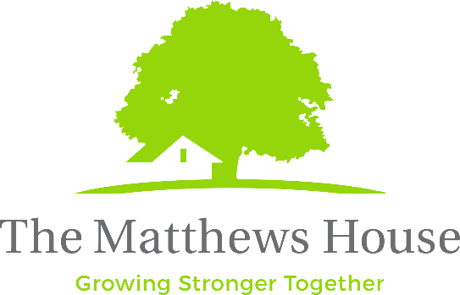
Live the Victory, Inc.

415 Mason Ct. #1

Fort Collins, CO 80524

Federal ID# 20-2894339

EQUAL OPPORTUNITY EMPLOYMENT & AFFIRMATIVE ACTION

The Matthews House is dedicated to the principles of equal employment opportunity in any term, condition, or privilege of employment. We do not discriminate against applicants or employees on the basis of age, race, sex, color, religion, national origin, disability or any other status protected by state or local law.

Position: Homework Helpers Intern
Unpaid position (course credit and fun work culture available!)

Homework Helpers is an after-school academic enrichment program that is operational Monday-Thursday between 3-6pm at multiple sites. Currently, we serve children in grades 2-8. The Homework Helpers Coordinators will lead each program site with the help of volunteers and interns. The goal is to maintain an academic and recreation environment that meets the needs of our clientele and facilitates a healthy and happy learning environment for the children of Fort Collins and Loveland.
Supervised by: Homework Helpers Coordinators
Key Responsibilities:
- Identify areas of support needed for present activities.
- Act as point of contact for staff, volunteers, and participants.
- Lead individual students in finding academic enrichment options.
- Help plan academic enrichment and community-building activities.
- Provide professional and prompt documentation as needed.
- Maintain compliance with The Matthews House CLC Protocols.

Qualifications:
- Individuals with excellent interpersonal skills who enjoy talking with children and adults in a non-threatening environment are the best candidates for this position
- Ability to engage and interact with students aged 8-14 in an academic and recreational context. Interested in the overall development and wellness of this age group.
- An openness to work with a variety of people from all walks of life and many cultures
- Clear verbal and written communication skills
- The ability to listen and quickly assess urgency for someone who might be in a crisis is helpful
- Possess dedication, commitment, tact, and enthusiasm for the CLC goals

Location: The Matthews House Community Life Center at First Pres and The Matthews House Community Life Center at Genesis Project

